**Budget Inn Webpage**

By: Vatsal Patel

Course: COMS 1333

Table of Contents

Description / Site Address / General Questions1

Home Page2

RoomsPage4

Reservation Page6

Directions Page8

Prices Page10

Grade Sheet12

Description

This webpage is made for local motel Budget Inn in Russellville, Ar. The purpose of this site is to let the customer know what facilities the motel offers and what type of rooms are available along with their prices. Also, provides customer with the option to reserve a room and navigation the motel.

Site Address

* <http://boole.cs.atu.edu/~vpatel4/COMS1333/Final/index.html>

FAQ

For this webpage I decided to use Hierarchical organization because it serves the home page well. Linking the home page to all other pages on the website. Also, I choose to use vertical navigation bar because it will be easy for the user to navigate through because the navigation menu always stays at the top of every page.

1. What is the reason for choosing the color scheme?
   * So, the hotel’s interior and exterior colors match the color scheme of the webpage.
2. Why are there not any back top links on web pages?
   * There is not any back to top links because the webpages are not relatively long. So, I don’t feel the need for them.

Home Page

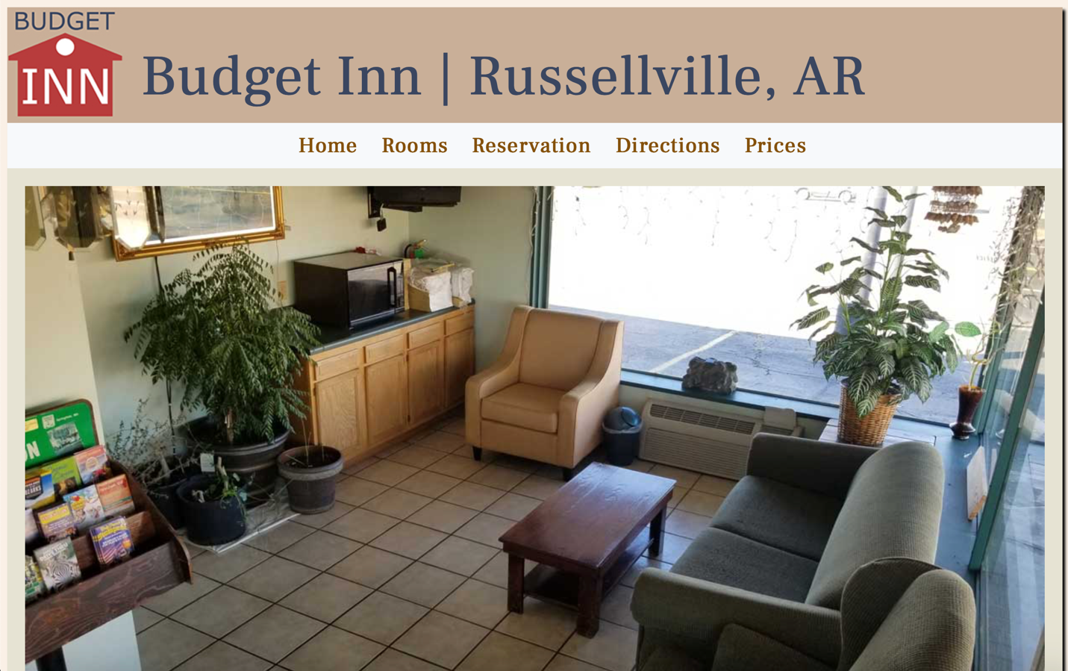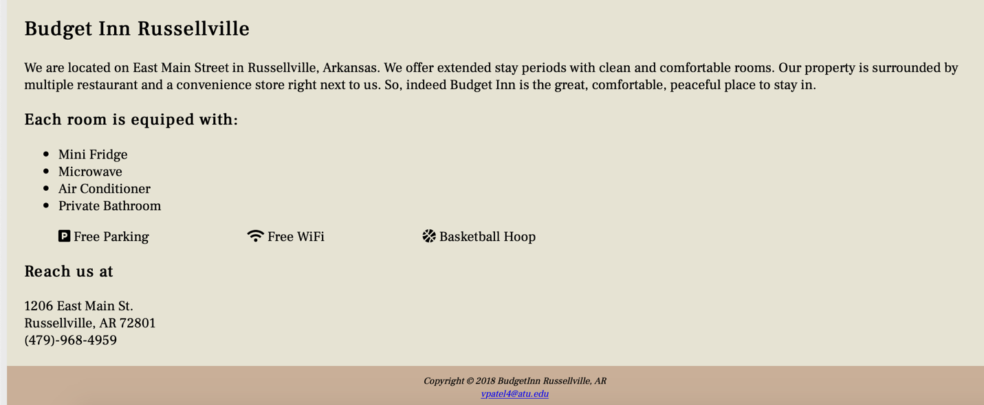

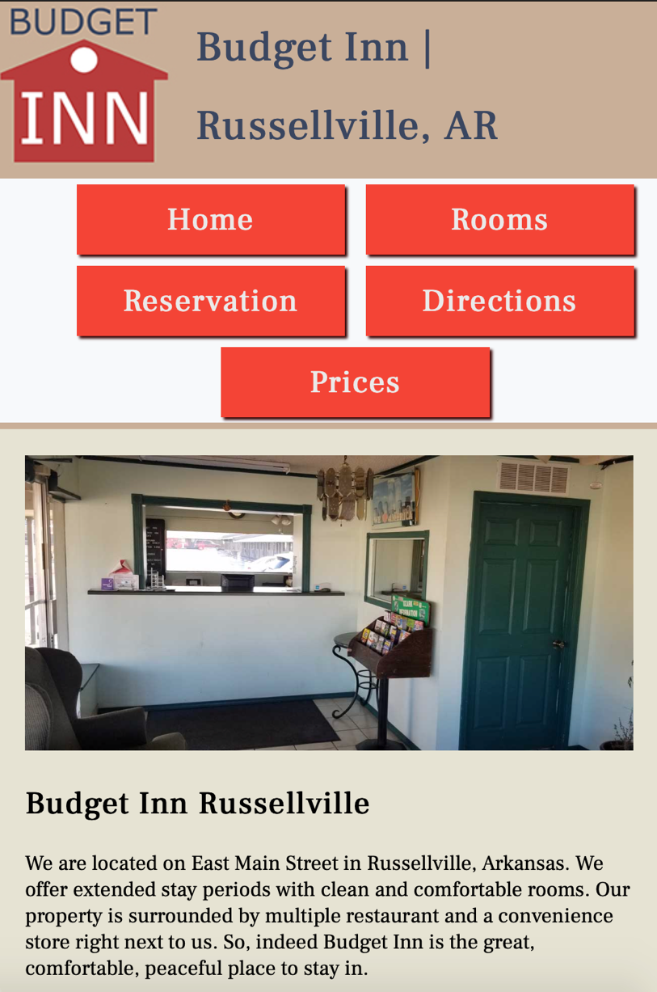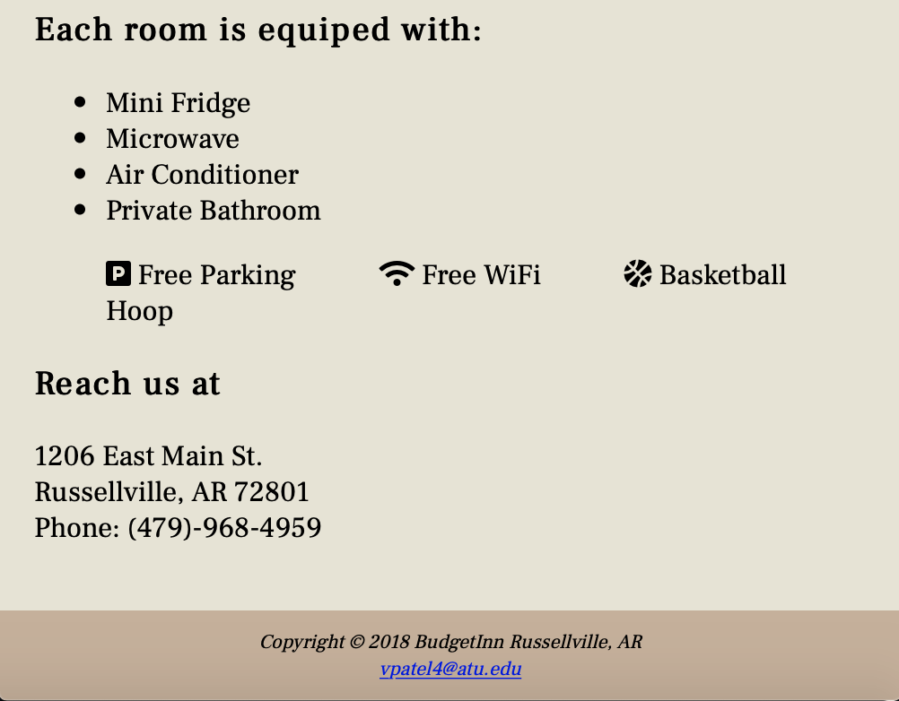

Rooms Page

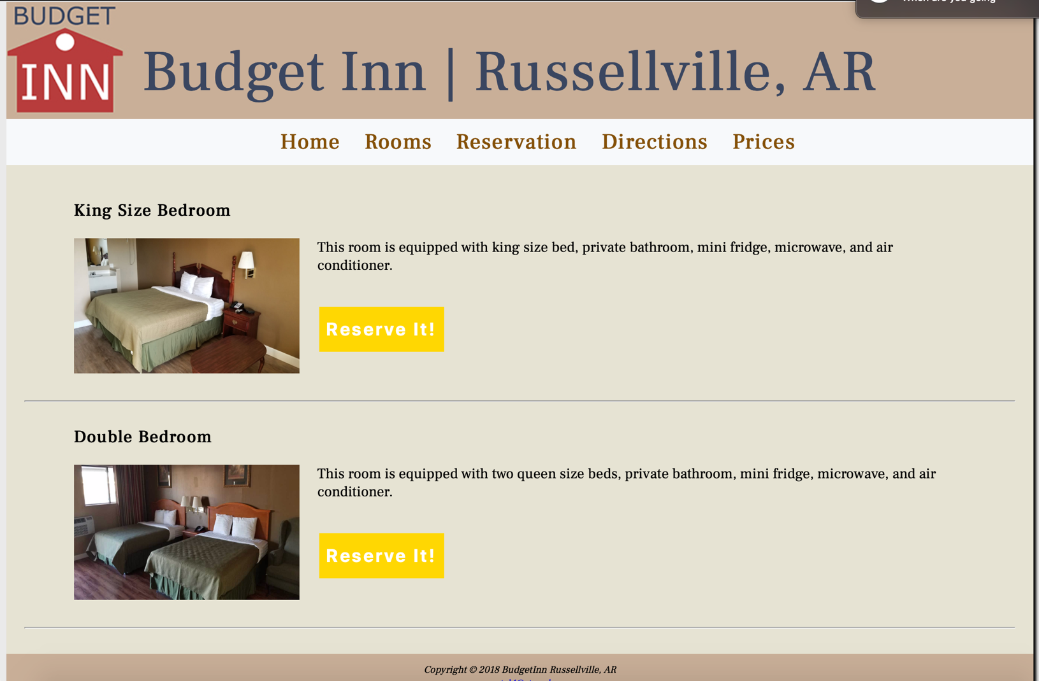

Mobile View of Rooms Page

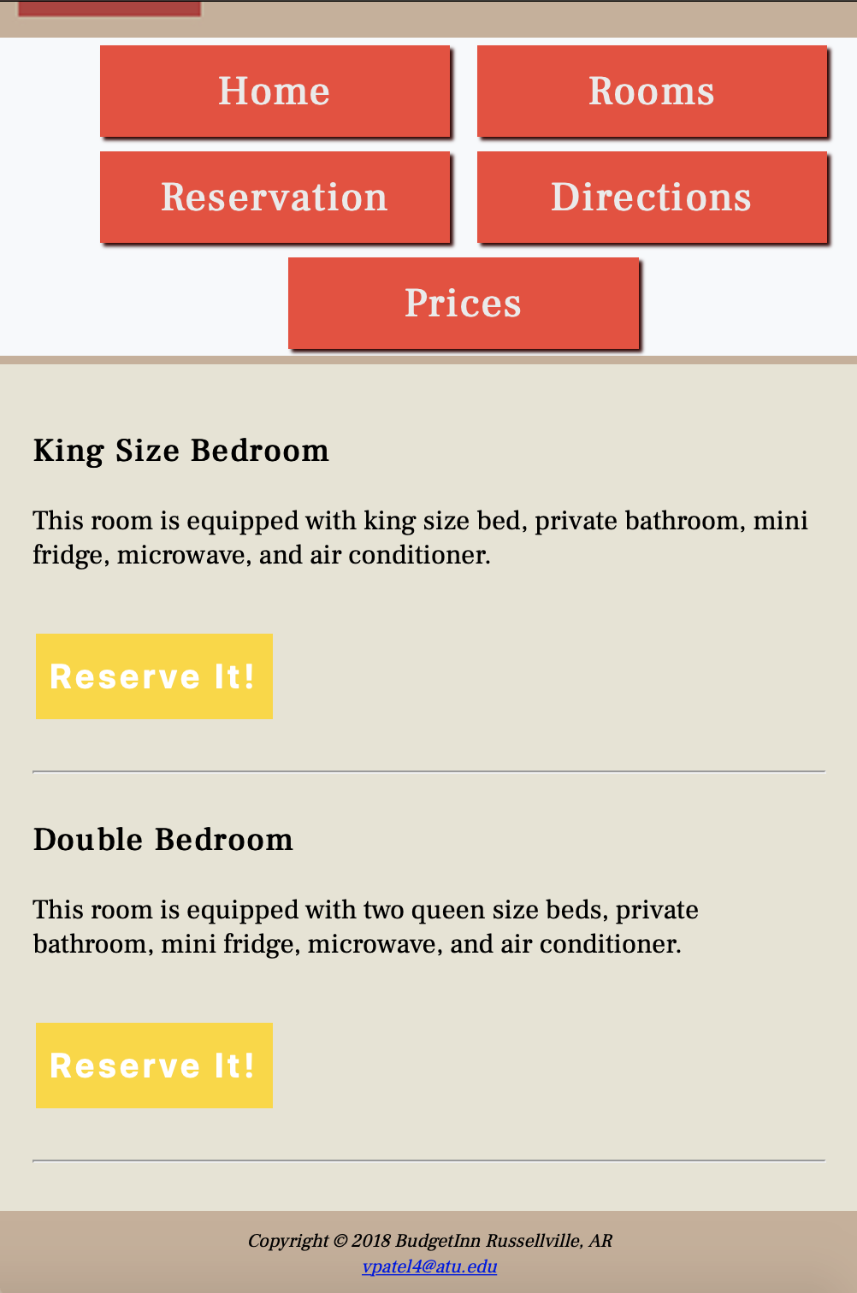

Reservation Page

Desktop View

Mobile View of Reservations Page

Directions Page

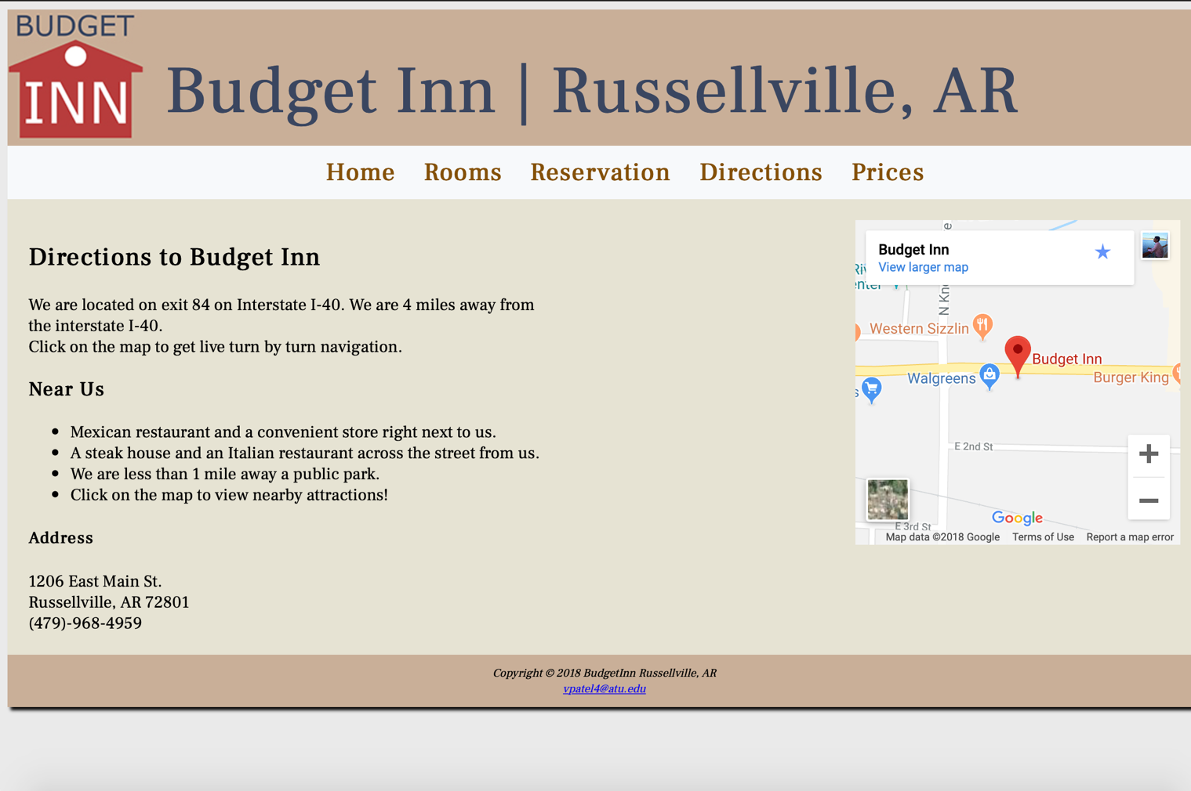

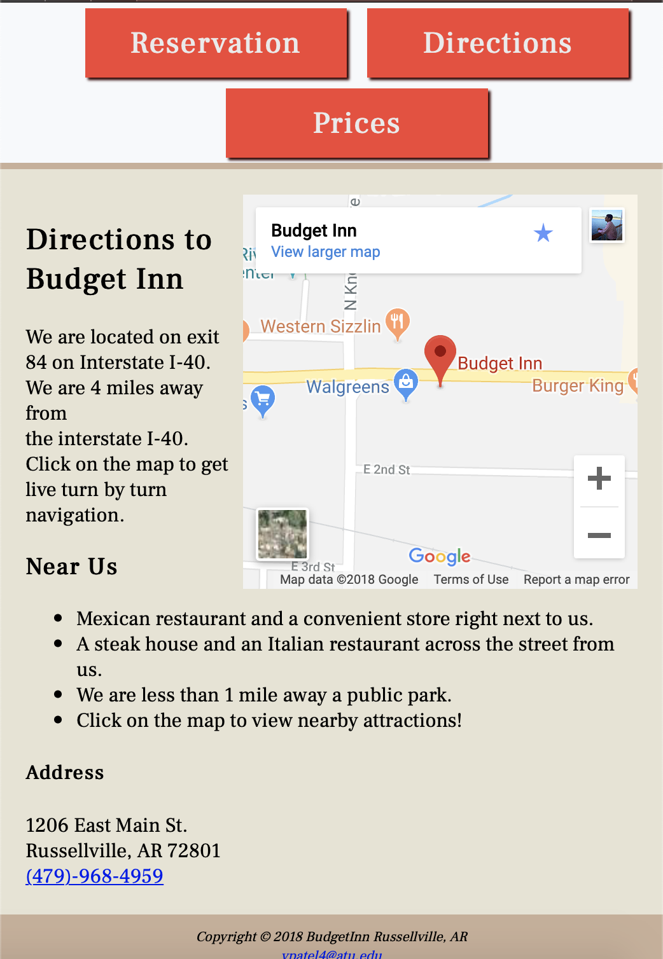Mobile View of Directions Page

Prices Page



Mobile View of Prices Page

